All | Packaging | Apparel & Accessories | Consumer Electronics

Brand name & Logo |  | Category
KIRKLAND SIGNATURE |  | All
SHOES UNDER |  | Packaging
Tetra Pak |  | Packaging
Dicota |  | Packaging
BOXWAVE |  | Packaging
KEYBOARD BUDDY |  | Packaging
Spiderpodium Tablet |  | Packaging
Breffo |  | Packaging
Beer Savers 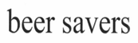 |  | Packaging
Dexion |  | Packaging
FRESHFIBER |  | Packaging
INOX CASE |  | Packaging
KATE SPADE NEW YORK |  | Packaging
Spider podium |  | Packaging
LONGOPAC  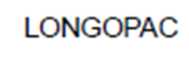 |  | Packaging
PAXXO |  | Packaging
POWER PRO 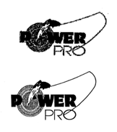 |  | Packaging
OVI |  | Packaging
Candyshell |  | Packaging
BOTTLE TOP |  | Packaging
XEROX |  | Packaging
X-design  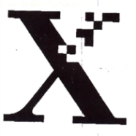 |  | Packaging
Acase |  | Packaging
Lighter Leash |  | Packaging
Thom Browne |  | Packaging
AnyLock |  | Packaging
cellophane |  | Packaging
DORNIER |  | Packaging
flip & tumble |  | Packaging
HARRODS |  | Packaging
HILFIGER |  | Packaging
RAINBOW LOOM |  | Packaging
Wish |  | Packaging
Miron |  | Packaging
ONITSUKA TIGER  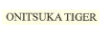 |  | Apparel & Accessories
NIALAYA  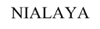 |  | Apparel & Accessories
PREMIER LEAGUE |  | Apparel & Accessories
PANDORA  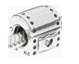 |  | Apparel & Accessories
7 For All Mankind |  | Apparel & Accessories
A&F |  | Apparel & Accessories
Arc'Teryx |  | Apparel & Accessories
Benetton |  | Apparel & Accessories
chrome hearts |  | Apparel & Accessories
Ck |  | Apparel & Accessories
cristobal balenciaga |  | Apparel & Accessories
Dior |  | Apparel & Accessories
donna karan new york |  | Apparel & Accessories
dsquared |  | Apparel & Accessories
emanuel ungaro  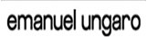 |  | Apparel & Accessories
Balenciaga  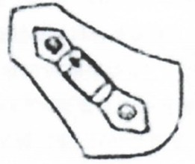 |  | Apparel & Accessories
Fischer |  | Apparel & Accessories
Furla |  | Apparel & Accessories
Gore-Tex |  | Apparel & Accessories
G-Star |  | Apparel & Accessories
gymboree  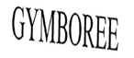 |  | Apparel & Accessories
HERMES  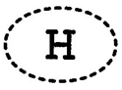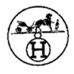 |  | Apparel & Accessories
Hollister Co. |  | Apparel & Accessories
ic! berlin |  | Apparel & Accessories
j.crew  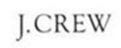 |  | Apparel & Accessories
Jack & Jones |  | Apparel & Accessories
Jack-Wolfskin |  | Apparel & Accessories
Juicy Couture |  | Apparel & Accessories
JumpFromPaper |  | Apparel & Accessories
Kenzo |  | Apparel & Accessories
Levis |  | Apparel & Accessories
long champ |  | Apparel & Accessories
loro piana  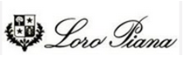 |  | Apparel & Accessories
LV |  | Apparel & Accessories
Lyle Scott |  | Apparel & Accessories
M.A.C |  | Apparel & Accessories
Michael Jordan |  | Apparel & Accessories
MIKASA |  | Apparel & Accessories
mitchell&ness |  | Apparel & Accessories
moschino |  | Apparel & Accessories
MOULIN ROUGE |  | Apparel & Accessories
No5 |  | Apparel & Accessories
Oscar De La Renta |  | Apparel & Accessories
PRADA  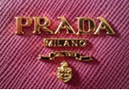 |  | Apparel & Accessories
Quicksilver 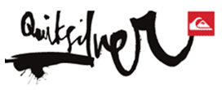 |  | Apparel & Accessories
Roberto Cavalli |  | Apparel & Accessories
rolling stones  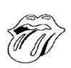 |  | Apparel & Accessories
Samsonite |  | Apparel & Accessories
Seven For All Mankind |  | Apparel & Accessories
Sinful |  | Apparel & Accessories
tiffany & co |  | Apparel & Accessories
TORY BURCH |  | Apparel & Accessories
Ysl  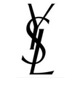 |  | Apparel & Accessories
3.1 Phillip Lim 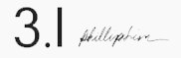 |  | Apparel & Accessories
MEXX |  | Apparel & Accessories
JANSPORT |  | Apparel & Accessories
EASTPAK |  | Apparel & Accessories
UNDER ARMOUR |  | Apparel & Accessories
DONNA KARAN |  | Apparel & Accessories
JESSICA |  | Apparel & Accessories
NBA |  | Apparel & Accessories
NBA  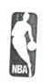 |  | Apparel & Accessories
Deuter |  | Apparel & Accessories
G2000  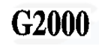 |  | Apparel & Accessories
H&M |  | Apparel & Accessories
Izzue  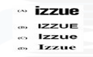 |  | Apparel & Accessories
Kookai |  | Apparel & Accessories
LeSportsac |  | Apparel & Accessories
Nissen |  | Apparel & Accessories
Quiksilver |  | Apparel & Accessories
Thursday Island |  | Apparel & Accessories
Tough |  | Apparel & Accessories
Uniqlo |  | Apparel & Accessories
Teenie Weenie  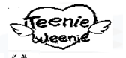 |  | Apparel & Accessories
Teenie Weenie |  | Apparel & Accessories
henri bendel |  | Apparel & Accessories
la senza |  | Apparel & Accessories
Lowa |  | Apparel & Accessories
Zamberlan |  | Apparel & Accessories
Adele Fado |  | Apparel & Accessories
Denis Simachev |  | Apparel & Accessories
Lancel |  | Apparel & Accessories
Valentino |  | Apparel & Accessories
Bossini |  | Apparel & Accessories
Versace |  | Apparel & Accessories
Collette Dinnigan  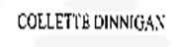 |  | Apparel & Accessories
Doc Martins |  | Apparel & Accessories
A BATHING APE |  | Apparel & Accessories
Cynthia Rowley 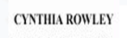 |  | Apparel & Accessories
Edmonton Oilers |  | Apparel & Accessories
Derek Lam |  | Apparel & Accessories
Fifa World Cup |  | Apparel & Accessories
Fifa |  | Apparel & Accessories
Glashutte Original |  | Apparel & Accessories
Gareth Pugh |  | Apparel & Accessories
Harrods |  | Apparel & Accessories
Goldlion |  | Apparel & Accessories
Porter |  | Apparel & Accessories
Lesmills |  | Apparel & Accessories
Lifted Research Group |  | Apparel & Accessories
Miami Heat  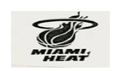 |  | Apparel & Accessories
PLAYBOY |  | Apparel & Accessories
WHY |  | Apparel & Accessories
Apee |  | Apparel & Accessories
Friendlies |  | Apparel & Accessories
Gazelle 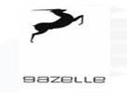 |  | Apparel & Accessories
Jeep |  | Apparel & Accessories
Merrell |  | Apparel & Accessories
Bossini |  | Apparel & Accessories
Ottawa Senators |  | Apparel & Accessories
PLAYBOY  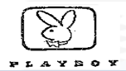 |  | Apparel & Accessories
Porter |  | Apparel & Accessories
Porter  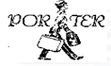 |  | Apparel & Accessories
Millet |  | Apparel & Accessories
New York Yankees |  | Apparel & Accessories
MK MICHAEL KORS |  | Apparel & Accessories
MORPHSUITS |  | Apparel & Accessories
Burkini |  | Apparel & Accessories
Burqini |  | Apparel & Accessories
Big Show |  | Apparel & Accessories
HHH  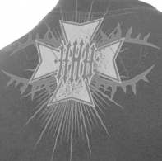 |  | Apparel & Accessories
Kane |  | Apparel & Accessories
Rey Mysterio  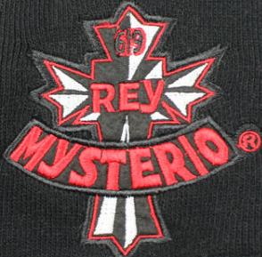 |  | Apparel & Accessories
Alberto Del Rio |  | Apparel & Accessories
Cenation |  | Apparel & Accessories
Boots To Asses |  | Apparel & Accessories
Batista |  | Apparel & Accessories
THE CAMBRIDGE SATCHEL COMPANY |  | Apparel & Accessories
trunki |  | Apparel & Accessories
Folli Follie  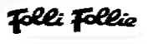 |  | Apparel & Accessories
Nine West |  | Apparel & Accessories
Camper  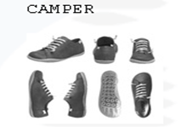 |  | Apparel & Accessories
Geox |  | Apparel & Accessories
Trippen |  | Apparel & Accessories
Santana day |  | Apparel & Accessories
Patricia |  | Apparel & Accessories
10deep  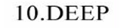 |  | Apparel & Accessories
winnipeg jets |  | Apparel & Accessories
Aldo |  | Apparel & Accessories
American Tourister  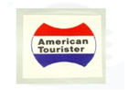 |  | Apparel & Accessories
ASOS |  | Apparel & Accessories
BCBG Max Azria |  | Apparel & Accessories
Cerruti 1881 |  | Apparel & Accessories
Buff |  | Apparel & Accessories
LE PLIAGE  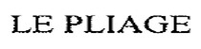 |  | Apparel & Accessories
SHERRI HILL |  | Apparel & Accessories
KELLY |  | Apparel & Accessories
Chris Jericho |  | Apparel & Accessories
John Cena |  | Apparel & Accessories
Shawn Michaels |  | Apparel & Accessories
Triple H 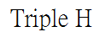 |  | Apparel & Accessories
Beth Phoenix |  | Apparel & Accessories
Randy Orton |  | Apparel & Accessories
Alex Riley  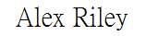 |  | Apparel & Accessories
C CHARRIOL |  | Apparel & Accessories
Roger dubuis  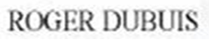 |  | Apparel & Accessories
Catorex |  | Apparel & Accessories
Edox |  | Apparel & Accessories
JMG |  | Apparel & Accessories
Louis Moinet 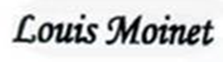 |  | Apparel & Accessories
Zeno-watch |  | Apparel & Accessories
Yema  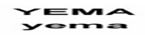 |  | Apparel & Accessories
BAUME & MERCIER GENEVE |  | Apparel & Accessories
Boucheron  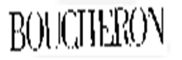 |  | Apparel & Accessories
ENZO |  | Apparel & Accessories
Girard-Perregaux |  | Apparel & Accessories
Graff |  | Apparel & Accessories
JOLEE boutique |  | Apparel & Accessories
MIKIMOTO |  | Apparel & Accessories
Oxette |  | Apparel & Accessories
Lladro |  | Apparel & Accessories
G-SHOCK |  | Apparel & Accessories
Victoria's Secret |  | Apparel & Accessories
EDIFICE |  | Apparel & Accessories
PRO TREK |  | Apparel & Accessories
OCEANUS |  | Apparel & Accessories
BABY-G  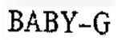 |  | Apparel & Accessories
Enicar |  | Apparel & Accessories
Ernest Borel |  | Apparel & Accessories
Jaeger |  | Apparel & Accessories
Orient |  | Apparel & Accessories
NAUTILUS PATEK PHILIPPE |  | Apparel & Accessories
Bell&Ross |  | Apparel & Accessories
Judith Leiber |  | Apparel & Accessories
Etonic |  | Apparel & Accessories
MOBY |  | Apparel & Accessories
CAMI SECRET |  | Apparel & Accessories
J12  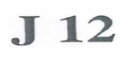 |  | Apparel & Accessories
KYMARO |  | Apparel & Accessories
CELTIC |  | Apparel & Accessories
ERMENEGILDO ZEGNA |  | Apparel & Accessories
SUPERDRY |  | Apparel & Accessories
DAINESE |  | Apparel & Accessories
Galina signature |  | Apparel & Accessories
VENUM |  | Apparel & Accessories
Pucci 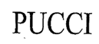 |  | Apparel & Accessories
FIT FLOP |  | Apparel & Accessories
FRANKLIN&MARSHALL |  | Apparel & Accessories
Frey Wille |  | Apparel & Accessories
boston Celtics  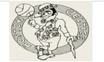 |  | Apparel & Accessories
denver Nuggets |  | Apparel & Accessories
Phoenix Suns  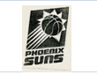 |  | Apparel & Accessories
Portland Blazers |  | Apparel & Accessories
Minnesota Timberwolves |  | Apparel & Accessories
New Orleans Hornets |  | Apparel & Accessories
Sacramento Kings |  | Apparel & Accessories
76ers  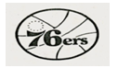 |  | Apparel & Accessories
Pacers |  | Apparel & Accessories
Memphis Grizzlies |  | Apparel & Accessories
CAMBRIDGE |  | Apparel & Accessories
Gina  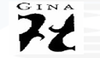 |  | Apparel & Accessories
Dune |  | Apparel & Accessories
A.Testoni |  | Apparel & Accessories
Bata 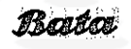 |  | Apparel & Accessories
Vasque |  | Apparel & Accessories
Rock & Republic |  | Apparel & Accessories
Rugby World Cup |  | Apparel & Accessories
Sleepy Wrap |  | Apparel & Accessories
Stackmat  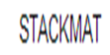 |  | Apparel & Accessories
Stephen Yearick  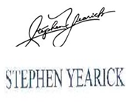 |  | Apparel & Accessories
Takeo Kikuchi |  | Apparel & Accessories
Toronto Maple Leafs |  | Apparel & Accessories
Tourbillon |  | Apparel & Accessories
Trikke |  | Apparel & Accessories
Ufc |  | Apparel & Accessories
Valdora  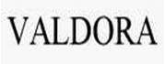 |  | Apparel & Accessories
Valentino  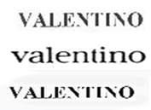 |  | Apparel & Accessories
Walkfit |  | Apparel & Accessories
Washington Capitals |  | Apparel & Accessories
KIEL JAMES PATRICK |  | Apparel & Accessories
KJP |  | Apparel & Accessories
Kikkerland |  | Apparel & Accessories
A.Lange & Sohne |  | Apparel & Accessories
Levi Strauss |  | Apparel & Accessories
Levi's |  | Apparel & Accessories
Links |  | Apparel & Accessories
TROLLBEADS |  | Apparel & Accessories
Lucky brand |  | Apparel & Accessories
Stella & Dot  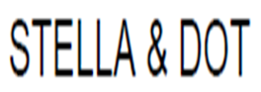 |  | Apparel & Accessories
MCM  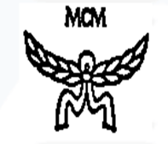 |  | Apparel & Accessories
Michael Kors 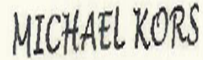 |  | Apparel & Accessories
Noo  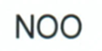 |  | Apparel & Accessories
Minnetonka |  | Apparel & Accessories
Minnetonka Moccasin |  | Apparel & Accessories
Houston Texans |  | Apparel & Accessories
Browns  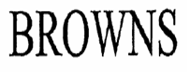 |  | Apparel & Accessories
I (HEART) PB  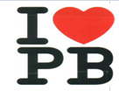 |  | Apparel & Accessories
PHILIPP PLEIN  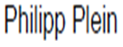 |  | Apparel & Accessories
PJS THAT OTHERS MAY LIVE PARAJUMPERS |  | Apparel & Accessories
PARAJUMPERS |  | Apparel & Accessories
ic! |  | Apparel & Accessories
ic  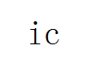 |  | Apparel & Accessories
ic!-berlin |  | Apparel & Accessories
RW RAYMOND WEIL GENEVE |  | Apparel & Accessories
Red Wing  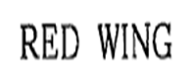 |  | Apparel & Accessories
RuffleButts  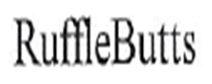 |  | Apparel & Accessories
s.Oliver |  | Apparel & Accessories
SP La Sposa |  | Apparel & Accessories
St. Patrick |  | Apparel & Accessories
DESIGNS BY SHERRI HILL |  | Apparel & Accessories
GIRARD-PERREGAUX |  | Apparel & Accessories
Body Geometry |  | Apparel & Accessories
SPIRIT HOODS  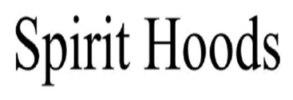 |  | Apparel & Accessories
STM |  | Apparel & Accessories
STRUTZ  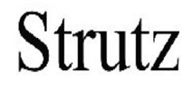 |  | Apparel & Accessories
ALUMA WALLET |  | Apparel & Accessories
BARE LIFTS |  | Apparel & Accessories
WINDSHIELD WONDER |  | Apparel & Accessories
PERFECT FIT BUTTON |  | Apparel & Accessories
kimmidoll  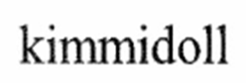 |  | Apparel & Accessories
Batchel |  | Apparel & Accessories
THE CAMBRIDGE SATCHEL BICYCLE  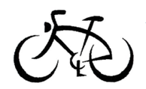 |  | Apparel & Accessories
THE NORTH FACE |  | Apparel & Accessories
T&CO.  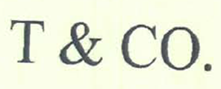 |  | Apparel & Accessories
ICE-WATCH |  | Apparel & Accessories
Tod's |  | Apparel & Accessories
Fay 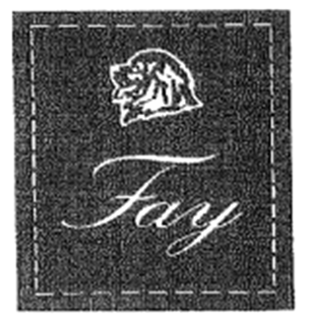 |  | Apparel & Accessories
TOLIX |  | Apparel & Accessories
JANIE AND JACK |  | Apparel & Accessories
PROTECTION  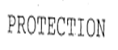 |  | Apparel & Accessories
G  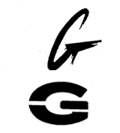 |  | Apparel & Accessories
ILLUMINATOR  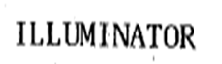 |  | Apparel & Accessories
zigtech  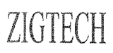 |  | Apparel & Accessories
EAGLE EYES |  | Apparel & Accessories
MILRY |  | Apparel & Accessories
XTR |  | Apparel & Accessories
Stradivarius  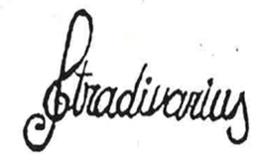 |  | Apparel & Accessories
BODE |  | Apparel & Accessories
AP |  | Apparel & Accessories
Undertaker |  | Apparel & Accessories
59Fifty (5950) (New Era系列)  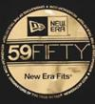 |  | Apparel & Accessories
7 For All Mankind (Seven For All Mankind) |  | Apparel & Accessories
A Bathing Ape |  | Apparel & Accessories
A. Lange & Sohne  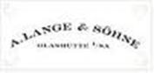 |  | Apparel & Accessories
Abercrombie & Fitch |  | Apparel & Accessories
Adidas  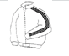 |  | Apparel & Accessories
Adolfo Dominguez |  | Apparel & Accessories
Adriana Castro |  | Apparel & Accessories
Affliction |  | Apparel & Accessories
Agnes B |  | Apparel & Accessories
Air Jordan  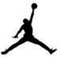 |  | Apparel & Accessories
Akademiks |  | Apparel & Accessories
Akris Punto |  | Apparel & Accessories
Alberta Ferretti  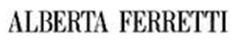 |  | Apparel & Accessories
Alberto Guardiani |  | Apparel & Accessories
Alejandro Ingelmo |  | Apparel & Accessories
Alexander McQueen |  | Apparel & Accessories
Alexander Wang |  | Apparel & Accessories
Alfred Angelo |  | Apparel & Accessories
Alice and Olivia  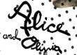 |  | Apparel & Accessories
Alife |  | Apparel & Accessories
Allsaints |  | Apparel & Accessories
Alpinestars |  | Apparel & Accessories
Amanda Pearl 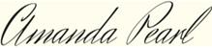 |  | Apparel & Accessories
Amaya Arzuaga |  | Apparel & Accessories
American Eagle  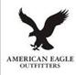 |  | Apparel & Accessories
Andrew GN |  | Apparel & Accessories
Anlo |  | Apparel & Accessories
Anna Molinari |  | Apparel & Accessories
Anna Sui |  | Apparel & Accessories
Anne Klein |  | Apparel & Accessories
Antik |  | Apparel & Accessories
Aquascutum |  | Apparel & Accessories
Arc'teryx |  | Apparel & Accessories
Armani |  | Apparel & Accessories
Asics |  | Apparel & Accessories
Audemars Piguet |  | Apparel & Accessories
AussieBum |  | Apparel & Accessories
Azzaro |  | Apparel & Accessories
Azzedine Alaia |  | Apparel & Accessories
BabyLegs  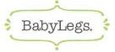 |  | Apparel & Accessories
BaByliss |  | Apparel & Accessories
Baby Phat  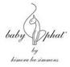 |  | Apparel & Accessories
Balenciaga  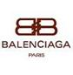 |  | Apparel & Accessories
Bally |  | Apparel & Accessories
Balmain |  | Apparel & Accessories
Barbour |  | Apparel & Accessories
Baume et Mercier |  | Apparel & Accessories
BBC (Billionaire Boys Club) |  | Apparel & Accessories
BCBG |  | Apparel & Accessories
Bebe |  | Apparel & Accessories
Bell & Ross |  | Apparel & Accessories
Belstaff  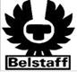 |  | Apparel & Accessories
Ben Sherman |  | Apparel & Accessories
Beretta |  | Apparel & Accessories
Betsey Johnson  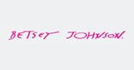 |  | Apparel & Accessories
Bijan  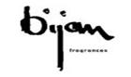 |  | Apparel & Accessories
Bikkembergs  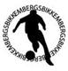 |  | Apparel & Accessories
Bill Blass |  | Apparel & Accessories
Billabong |  | Apparel & Accessories
Birkenstock |  | Apparel & Accessories
Birkin |  | Apparel & Accessories
Bjorn Borg  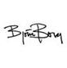 |  | Apparel & Accessories
Blac Label |  | Apparel & Accessories
Bon Bebe |  | Apparel & Accessories
Bossini |  | Apparel & Accessories
Bottega Veneta |  | Apparel & Accessories
Bourjois |  | Apparel & Accessories
Breguet  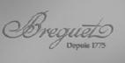 |  | Apparel & Accessories
Breitling |  | Apparel & Accessories
Brian Atwood |  | Apparel & Accessories
Brioni |  | Apparel & Accessories
Buff  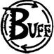 |  | Apparel & Accessories
Bulova  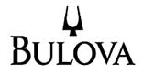 |  | Apparel & Accessories
Burberry |  | Apparel & Accessories
Bvlgari  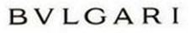 |  | Apparel & Accessories
Cacharel |  | Apparel & Accessories
C1rca |  | Apparel & Accessories
Callaway |  | Apparel & Accessories
Calvin Klein  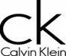 |  | Apparel & Accessories
Cambrella |  | Apparel & Accessories
Camelbak |  | Apparel & Accessories
Canada Goose |  | Apparel & Accessories
Cannondale |  | Apparel & Accessories
Carachel |  | Apparel & Accessories
Carmen Marc Valvo |  | Apparel & Accessories
Carmex |  | Apparel & Accessories
Carolina Herrera |  | Apparel & Accessories
Carrera |  | Apparel & Accessories
Cartier |  | Apparel & Accessories
Casadei |  | Apparel & Accessories
Casio |  | Apparel & Accessories
CAT |  | Apparel & Accessories
Cath Kidston |  | Apparel & Accessories
Catherine Malandrino |  | Apparel & Accessories
Catimini |  | Apparel & Accessories
Cavalli |  | Apparel & Accessories
Celine |  | Apparel & Accessories
Champion |  | Apparel & Accessories
Chanel |  | Apparel & Accessories
Charles David |  | Apparel & Accessories
Chaumet |  | Apparel & Accessories
Cheap Monday |  | Apparel & Accessories
Chloe  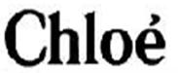 |  | Apparel & Accessories
Chopard  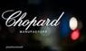 |  | Apparel & Accessories
Chris Benz |  | Apparel & Accessories
Christian Audigier  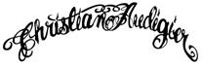 |  | Apparel & Accessories
Christian Dior |  | Apparel & Accessories
Christian Lacroix |  | Apparel & Accessories
Christian Louboutin  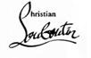 |  | Apparel & Accessories
Citizen |  | Apparel & Accessories
Clarks |  | Apparel & Accessories
Cleveland |  | Apparel & Accessories
Coach |  | Apparel & Accessories
Cobra |  | Apparel & Accessories
Cole Haan |  | Apparel & Accessories
Colin Stuart |  | Apparel & Accessories
Collette Dinnigan  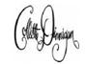 |  | Apparel & Accessories
Columbia |  | Apparel & Accessories
Comme Des Garcons  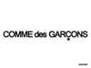 |  | Apparel & Accessories
Concord |  | Apparel & Accessories
Converse |  | Apparel & Accessories
Coogi |  | Apparel & Accessories
Coola Hula Skirt  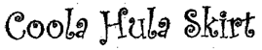 |  | Apparel & Accessories
Corum  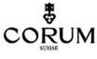 |  | Apparel & Accessories
Creative |  | Apparel & Accessories
Cristóbal Balenciaga |  | Apparel & Accessories
Crocs |  | Apparel & Accessories
Crown Holder |  | Apparel & Accessories
Dana Buchman |  | Apparel & Accessories
Daniel Roth |  | Apparel & Accessories
David Yurman |  | Apparel & Accessories
Davidoff |  | Apparel & Accessories
DC |  | Apparel & Accessories
Debbie Meyer |  | Apparel & Accessories
Denis Simachev |  | Apparel & Accessories
Derek Lam |  | Apparel & Accessories
Diadora |  | Apparel & Accessories
Diane Von Furstenberg |  | Apparel & Accessories
Diesel |  | Apparel & Accessories
Disney |  | Apparel & Accessories
Disneyland |  | Apparel & Accessories
DKNY |  | Apparel & Accessories
Dolce & Gabbana (D&G) 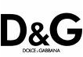 |  | Apparel & Accessories
Dom Rebel |  | Apparel & Accessories
Dooney & Bourke  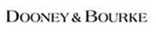 |  | Apparel & Accessories
Dopie |  | Apparel & Accessories
Douglas Hannant |  | Apparel & Accessories
Dr. Martens |  | Apparel & Accessories
Dries Van Noten |  | Apparel & Accessories
DSquared2  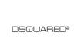 |  | Apparel & Accessories
Duchamp |  | Apparel & Accessories
Dunhill |  | Apparel & Accessories
Dunlop |  | Apparel & Accessories
Duvetica  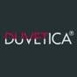 |  | Apparel & Accessories
DVF  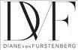 |  | Apparel & Accessories
Ebel |  | Apparel & Accessories
Ecco |  | Apparel & Accessories
Ecko |  | Apparel & Accessories
Ed Hardy  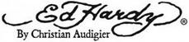 |  | Apparel & Accessories
EFX |  | Apparel & Accessories
Eley Kishimoto |  | Apparel & Accessories
Elle  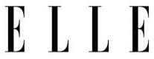 |  | Apparel & Accessories
Emilio Pucci |  | Apparel & Accessories
Energie |  | Apparel & Accessories
Erickson Beamon |  | Apparel & Accessories
Escada |  | Apparel & Accessories
Esprit |  | Apparel & Accessories
Everlast |  | Apparel & Accessories
Evisu |  | Apparel & Accessories
Fendi |  | Apparel & Accessories
Fila |  | Apparel & Accessories
Fitflop |  | Apparel & Accessories
Fischer |  | Apparel & Accessories
FjallRaven |  | Apparel & Accessories
Forever 21 |  | Apparel & Accessories
Fossil |  | Apparel & Accessories
Fox Head |  | Apparel & Accessories
Franck Muller |  | Apparel & Accessories
Franco Moschino |  | Apparel & Accessories
Franklin Marshall |  | Apparel & Accessories
Fred Leighton  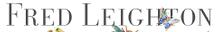 |  | Apparel & Accessories
Fred Perry |  | Apparel & Accessories
Galliano |  | Apparel & Accessories
Gant |  | Apparel & Accessories
GAP |  | Apparel & Accessories
Gareth Pugh |  | Apparel & Accessories
Geren Ford  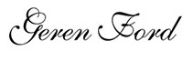 |  | Apparel & Accessories
Giambattista Valli |  | Apparel & Accessories
Gianfranco Ferré |  | Apparel & Accessories
Gianmarco Lorenzi |  | Apparel & Accessories
Giuseppe Zanotti 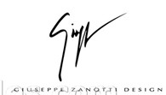 |  | Apparel & Accessories
Givenchy |  | Apparel & Accessories
Glashutte Original |  | Apparel & Accessories
Golla |  | Apparel & Accessories
Gore-Tex  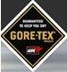 |  | Apparel & Accessories
Goyard |  | Apparel & Accessories
Graeme Black  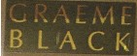 |  | Apparel & Accessories
Graham |  | Apparel & Accessories
Grai |  | Apparel & Accessories
Gray Nicolls |  | Apparel & Accessories
Greedy Genius |  | Apparel & Accessories
Gretsch |  | Apparel & Accessories
G-Shock (Casio的手表系列) |  | Apparel & Accessories
G-Star Raw |  | Apparel & Accessories
Gucci  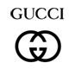 |  | Apparel & Accessories
Guess |  | Apparel & Accessories
Hache  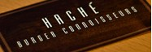 |  | Apparel & Accessories
Hackett |  | Apparel & Accessories
Haglofs  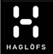 |  | Apparel & Accessories
Haider Ackerman  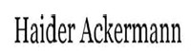 |  | Apparel & Accessories
Hamilton |  | Apparel & Accessories
Hanae Mori |  | Apparel & Accessories
Hanii Y  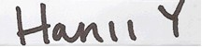 |  | Apparel & Accessories
Harry Winston |  | Apparel & Accessories
Havaianas |  | Apparel & Accessories
helena rubinstein |  | Apparel & Accessories
Helmut Lang |  | Apparel & Accessories
Hermes |  | Apparel & Accessories
Herve Leger |  | Apparel & Accessories
Hogan |  | Apparel & Accessories
Hollister Co |  | Apparel & Accessories
Hublot |  | Apparel & Accessories
Hugo Boss |  | Apparel & Accessories
Hurley  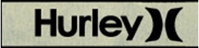 |  | Apparel & Accessories
Ibanez |  | Apparel & Accessories
Ilse Jacobsen |  | Apparel & Accessories
Insanity |  | Apparel & Accessories
Irene Galitzine |  | Apparel & Accessories
iRenew |  | Apparel & Accessories
Isabel Toledo  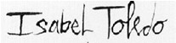 |  | Apparel & Accessories
Issa London |  | Apparel & Accessories
Issey Miyake  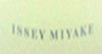 |  | Apparel & Accessories
IWC |  | Apparel & Accessories
J. Crew |  | Apparel & Accessories
Jack Jones |  | Apparel & Accessories
Jack Wills |  | Apparel & Accessories
Jack Wolfskin |  | Apparel & Accessories
Jacob & Co. |  | Apparel & Accessories
Jaeger Lecoultre |  | Apparel & Accessories
Jason Wu |  | Apparel & Accessories
Jawbone |  | Apparel & Accessories
Jay Godfrey |  | Apparel & Accessories
Jazzy Toes |  | Apparel & Accessories
Jean Paul Gaultier |  | Apparel & Accessories
Jeep |  | Apparel & Accessories
Jemella Ltd |  | Apparel & Accessories
Jennifer Lopez |  | Apparel & Accessories
Jessica McClintock |  | Apparel & Accessories
Jhane Barnes |  | Apparel & Accessories
Jil Sander |  | Apparel & Accessories
Jimmy Choo |  | Apparel & Accessories
John Galliano  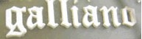 |  | Apparel & Accessories
Jonathan Saunders |  | Apparel & Accessories
Judith Ripka |  | Apparel & Accessories
Juicy Couture |  | Apparel & Accessories
Junya Watanabe 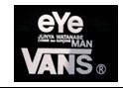 |  | Apparel & Accessories
Kaporal  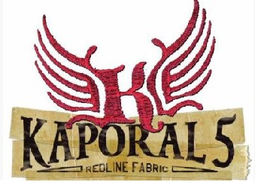 |  | Apparel & Accessories
Kappa |  | Apparel & Accessories
Karen Millen |  | Apparel & Accessories
Karl Lagerfeld |  | Apparel & Accessories
Kate Spade |  | Apparel & Accessories
Keen  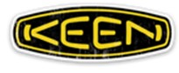 |  | Apparel & Accessories
Kenneth Cole |  | Apparel & Accessories
Kenzo Takada |  | Apparel & Accessories
Kimora Lee Simmons |  | Apparel & Accessories
Kipling |  | Apparel & Accessories
Kitson |  | Apparel & Accessories
Kobe |  | Apparel & Accessories
Koi Suwannagate  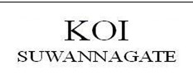 |  | Apparel & Accessories
Kona  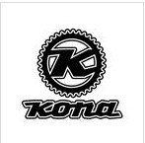 |  | Apparel & Accessories
Kooba |  | Apparel & Accessories
Ksubi |  | Apparel & Accessories
La Martina  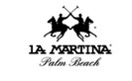 |  | Apparel & Accessories
Le Coq Sportif  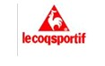 |  | Apparel & Accessories
La Mer |  | Apparel & Accessories
La Prairie |  | Apparel & Accessories
Lacoste |  | Apparel & Accessories
Laguna Beach |  | Apparel & Accessories
Laila Azhar |  | Apparel & Accessories
Lane Bryant |  | Apparel & Accessories
Lanvin |  | Apparel & Accessories
Laura Bennett |  | Apparel & Accessories
Lauren Moffatt |  | Apparel & Accessories
Lee |  | Apparel & Accessories
Leg Avenue |  | Apparel & Accessories
Lela Rose |  | Apparel & Accessories
Leo Schachter |  | Apparel & Accessories
Lesmills |  | Apparel & Accessories
Levi's |  | Apparel & Accessories
Lida Baday  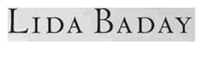 |  | Apparel & Accessories
Lifted Research Group (LRG) |  | Apparel & Accessories
Links of London  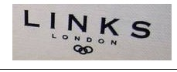 |  | Apparel & Accessories
Lisa Perry |  | Apparel & Accessories
Livestrong |  | Apparel & Accessories
Liz Claiborne |  | Apparel & Accessories
Loeffler Randall |  | Apparel & Accessories
Loewe |  | Apparel & Accessories
Longchamp |  | Apparel & Accessories
Longines |  | Apparel & Accessories
Lonsdale |  | Apparel & Accessories
Louis Vuitton (LV) |  | Apparel & Accessories
Luigi Loro Piana |  | Apparel & Accessories
Luminox |  | Apparel & Accessories
Lyle & Scott |  | Apparel & Accessories
Mad Foot |  | Apparel & Accessories
Maggie Sottero |  | Apparel & Accessories
Mammut |  | Apparel & Accessories
Manchester United |  | Apparel & Accessories
Manolo Blahnik |  | Apparel & Accessories
Mara Hoffman  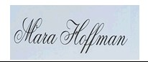 |  | Apparel & Accessories
Marc Jacobs |  | Apparel & Accessories
Marchesa |  | Apparel & Accessories
Mariah Carey |  | Apparel & Accessories
Mauri |  | Apparel & Accessories
Max Azria  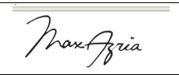 |  | Apparel & Accessories
Max Mara |  | Apparel & Accessories
MBT |  | Apparel & Accessories
Merrell |  | Apparel & Accessories
Metal Mulisha |  | Apparel & Accessories
Miffy |  | Apparel & Accessories
Millets |  | Apparel & Accessories
Miss Sixty |  | Apparel & Accessories
Miu Miu  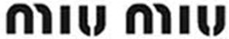 |  | Apparel & Accessories
Mizuno |  | Apparel & Accessories
MLB (Major League Baseball)  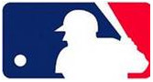 |  | Apparel & Accessories
New York Knicks (NBA队伍)  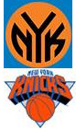 |  | Apparel & Accessories
Lin Shuhao 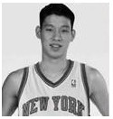 |  | Apparel & Accessories
Mon Cheri Bridals |  | Apparel & Accessories
Monarchy |  | Apparel & Accessories
Moncler  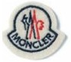 |  | Apparel & Accessories
Moon Boot |  | Apparel & Accessories
Movado |  | Apparel & Accessories
Mulberry
Apparel & Accessories
Munich |  | Apparel & Accessories
Nanette Lepore |  | Apparel & Accessories
NBA |  | Apparel & Accessories
New Balance |  | Apparel & Accessories
New Era |  | Apparel & Accessories
NFL (National Football League) |  | Apparel & Accessories
NHL |  | Apparel & Accessories
Nike (Nike Shox)  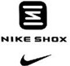 |  | Apparel & Accessories
Nina Ricci  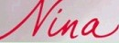 |  | Apparel & Accessories
Nino Cerruti |  | Apparel & Accessories
Nixon |  | Apparel & Accessories
Nubra  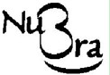 |  | Apparel & Accessories
Nuxe |  | Apparel & Accessories
Oakley |  | Apparel & Accessories
Odyssey |  | Apparel & Accessories
Omega |  | Apparel & Accessories
Onesies |  | Apparel & Accessories
Oris |  | Apparel & Accessories
Oscar De Larenta  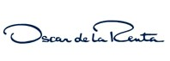 |  | Apparel & Accessories
Osiris |  | Apparel & Accessories
Ozark 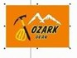 |  | Apparel & Accessories
P90X |  | Apparel & Accessories
Paco Chicano |  | Apparel & Accessories
Paco Rabanne |  | Apparel & Accessories
Pandora |  | Apparel & Accessories
Panerai |  | Apparel & Accessories
Parnis |  | Apparel & Accessories
Patek Philippe |  | Apparel & Accessories
Paul Frank |  | Apparel & Accessories
Paul Shark |  | Apparel & Accessories
Paul Smith |  | Apparel & Accessories
Peak  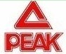 |  | Apparel & Accessories
Pegah Anvarian |  | Apparel & Accessories
Perry Ellis |  | Apparel & Accessories
Peter Som |  | Apparel & Accessories
Peuterey |  | Apparel & Accessories
Phiten |  | Apparel & Accessories
Piaget |  | Apparel & Accessories
Piazza Sempione |  | Apparel & Accessories
Pierre Cardin |  | Apparel & Accessories
Ping |  | Apparel & Accessories
Police |  | Apparel & Accessories
Polo Ralph Lauren  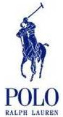 |  | Apparel & Accessories
Pony  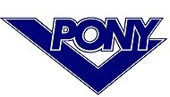 |  | Apparel & Accessories
Porsche Design |  | Apparel & Accessories
Power Balance  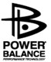 |  | Apparel & Accessories
Prada  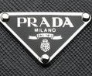 |  | Apparel & Accessories
Proenza Schouler |  | Apparel & Accessories
Pronovias |  | Apparel & Accessories
Pulsar |  | Apparel & Accessories
Puma  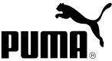 |  | Apparel & Accessories
Purse Brite |  | Apparel & Accessories
Quiksilver |  | Apparel & Accessories
Rachel Roy |  | Apparel & Accessories
Radii |  | Apparel & Accessories
Rado |  | Apparel & Accessories
Ralph Lauren |  | Apparel & Accessories
Ray Ban  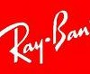 |  | Apparel & Accessories
Reebok |  | Apparel & Accessories
Remo Gianni |  | Apparel & Accessories
Rei Kawakubo |  | Apparel & Accessories
Replay |  | Apparel & Accessories
Richard Mille |  | Apparel & Accessories
Rick Owens  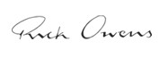 |  | Apparel & Accessories
Rip Curl |  | Apparel & Accessories
Robert Clergerie  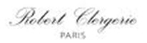 |  | Apparel & Accessories
Roberto Capucci |  | Apparel & Accessories
Robins Jean |  | Apparel & Accessories
Roca Wear |  | Apparel & Accessories
Rock & Republic  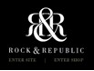 |  | Apparel & Accessories
Rodarte |  | Apparel & Accessories
Roger Dubuis |  | Apparel & Accessories
Rolex |  | Apparel & Accessories
Romain Jerome |  | Apparel & Accessories
Romero Britto  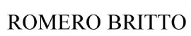 |  | Apparel & Accessories
Roundtree & Richardson |  | Apparel & Accessories
Roxy 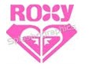 |  | Apparel & Accessories
Rozae Nichols |  | Apparel & Accessories
Rugby World Cup (Rugby World Cup 2011) |  | Apparel & Accessories
Salvatore Ferragamo  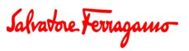 |  | Apparel & Accessories
Samantha Thavasa |  | Apparel & Accessories
Saress |  | Apparel & Accessories
Scotch Soda |  | Apparel & Accessories
Scotty Cameron |  | Apparel & Accessories
Seamaster |  | Apparel & Accessories
Sean John |  | Apparel & Accessories
Sebago |  | Apparel & Accessories
Seiko |  | Apparel & Accessories
Sergio Rossi |  | Apparel & Accessories
Shipley & Halmos  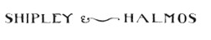 |  | Apparel & Accessories
Silly Bandz |  | Apparel & Accessories
Sinful (Affliction系列) |  | Apparel & Accessories
Skechers |  | Apparel & Accessories
Skip Hop |  | Apparel & Accessories
Spyder |  | Apparel & Accessories
Square D |  | Apparel & Accessories
Stefano Pilati |  | Apparel & Accessories
Stefano Ricci  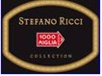 |  | Apparel & Accessories
Stella McCartney |  | Apparel & Accessories
Stephen Yearick  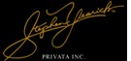 |  | Apparel & Accessories
Steve Madden |  | Apparel & Accessories
Stone Island |  | Apparel & Accessories
Strenesse |  | Apparel & Accessories
Stuart Weitzman |  | Apparel & Accessories
Submariner (Rolex系列) |  | Apparel & Accessories
Supra |  | Apparel & Accessories
Supra Footwear  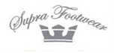 |  | Apparel & Accessories
Supra Tuf |  | Apparel & Accessories
Swatch |  | Apparel & Accessories
Swarovski |  | Apparel & Accessories
Tag Heuer  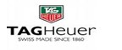 |  | Apparel & Accessories
Tahari |  | Apparel & Accessories
Takeshy Kurosawa |  | Apparel & Accessories
Tapout  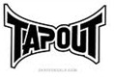 |  | Apparel & Accessories
Tasco |  | Apparel & Accessories
Taylormade |  | Apparel & Accessories
Tech Deck |  | Apparel & Accessories
Ted Baker |  | Apparel & Accessories
Temperley |  | Apparel & Accessories
Terranova |  | Apparel & Accessories
Terra Plana |  | Apparel & Accessories
Textilene |  | Apparel & Accessories
Thakoon |  | Apparel & Accessories
The North Face |  | Apparel & Accessories
Thierry Mugler |  | Apparel & Accessories
Thomas Burberry |  | Apparel & Accessories
Thomas Pink |  | Apparel & Accessories
Thomas Sabo 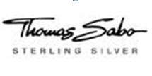 |  | Apparel & Accessories
Thomas Wylde |  | Apparel & Accessories
Tiffany & Co.  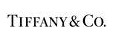 |  | Apparel & Accessories
Tiffany Rose |  | Apparel & Accessories
Timberland |  | Apparel & Accessories
Timex |  | Apparel & Accessories
Tissot |  | Apparel & Accessories
Titleist (Titleist Pro V)  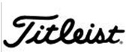 |  | Apparel & Accessories
Titoni |  | Apparel & Accessories
Todd Oldham |  | Apparel & Accessories
Tod's |  | Apparel & Accessories
Tokidoki |  | Apparel & Accessories
Tom Ford |  | Apparel & Accessories
Tommy Hilfiger |  | Apparel & Accessories
Toms  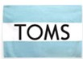 |  | Apparel & Accessories
Tonino Lamborghini |  | Apparel & Accessories
Tory Burch |  | Apparel & Accessories
Tous  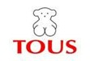 |  | Apparel & Accessories
Tower 200 (Body by Jake系列) |  | Apparel & Accessories
Toy Watch |  | Apparel & Accessories
Tracy Reese |  | Apparel & Accessories
Triangle Chalk  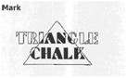 |  | Apparel & Accessories
True Religion |  | Apparel & Accessories
TSE |  | Apparel & Accessories
Tudor |  | Apparel & Accessories
Tuleh |  | Apparel & Accessories
Turbo Jam |  | Apparel & Accessories
Ubiq |  | Apparel & Accessories
U-Boat |  | Apparel & Accessories
UFC |  | Apparel & Accessories
Ugg |  | Apparel & Accessories
Ulysse Nardin |  | Apparel & Accessories
Umbro |  | Apparel & Accessories
Under Armour |  | Apparel & Accessories
Ungaro |  | Apparel & Accessories
United Colors of Benetton |  | Apparel & Accessories
Vacheron Constantin |  | Apparel & Accessories
Valentino Garavani  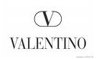 |  | Apparel & Accessories
Vans  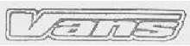 |  | Apparel & Accessories
Vena Cava |  | Apparel & Accessories
Vera Bradley |  | Apparel & Accessories
Vera Wang |  | Apparel & Accessories
Vero Moda |  | Apparel & Accessories
Versace |  | Apparel & Accessories
Vibram  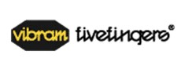 |  | Apparel & Accessories
Victoria's Secret |  | Apparel & Accessories
Vince |  | Apparel & Accessories
Vivienne Westwood |  | Apparel & Accessories
Vlado |  | Apparel & Accessories
Volcom |  | Apparel & Accessories
Volkl |  | Apparel & Accessories
Von Dutch |  | Apparel & Accessories
Welder |  | Apparel & Accessories
Wilson |  | Apparel & Accessories
Wolford |  | Apparel & Accessories
Wrangler  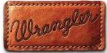 |  | Apparel & Accessories
Yigal Azroul |  | Apparel & Accessories
Yohji Yamamoto  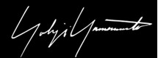 |  | Apparel & Accessories
Yonex |  | Apparel & Accessories
Yves Saint Laurent |  | Apparel & Accessories
Zac Posen |  | Apparel & Accessories
Zakumi (FIFA南非世界杯商标)  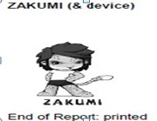 |  | Apparel & Accessories
Zara |  | Apparel & Accessories
Zegna |  | Apparel & Accessories
Zenith |  | Apparel & Accessories
5.11 |  | Apparel & Accessories
9FIFTY |  | Apparel & Accessories
arsenal  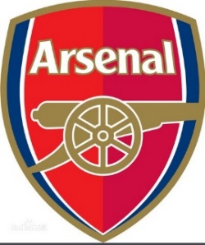 |  | Apparel & Accessories
manchester city |  | Apparel & Accessories
l.f.c. |  | Apparel & Accessories
180S |  | Apparel & Accessories
SKIP HOP |  | Apparel & Accessories
Chelsea FC |  | Apparel & Accessories
Alhambra |  | Apparel & Accessories
Allure Bridals |  | Apparel & Accessories
Alpine Swiss |  | Apparel & Accessories
Androextender |  | Apparel & Accessories
ARDELL |  | Apparel & Accessories
Atlanta Hawks |  | Apparel & Accessories
AUTOMOBILI LAMBORGHINI |  | Apparel & Accessories
B BOGNER |  | Apparel & Accessories
backjoy |  | Apparel & Accessories
BAD BOY |  | Apparel & Accessories
BAREFOOT DREAMS |  | Apparel & Accessories
Batman |  | Apparel & Accessories
Baume & Mercier |  | Apparel & Accessories
BEAUTYBLENDER |  | Apparel & Accessories
bebe |  | Apparel & Accessories
Bell&Ross |  | Apparel & Accessories
BENCH |  | Apparel & Accessories
BENCH. |  | Apparel & Accessories
BERSHKA |  | Apparel & Accessories
Bico Australia |  | Apparel & Accessories
Blee Inara |  | Apparel & Accessories
BLOCH |  | Apparel & Accessories
Bogner |  | Apparel & Accessories
BOTOMASK |  | Apparel & Accessories
Brixton |  | Apparel & Accessories
BTB 97 |  | Apparel & Accessories
BUCKLE |  | Apparel & Accessories
BUFF |  | Apparel & Accessories
Burkini |  | Apparel & Accessories
Burqini |  | Apparel & Accessories
Case Logic |  | Apparel & Accessories
CELEB Boutique |  | Apparel & Accessories
CELTIC |  | Apparel & Accessories
chanel |  | Apparel & Accessories
Charlotte Olympia |  | Apparel & Accessories
CHICAGO BULLS |  | Apparel & Accessories
ChicoBag |  | Apparel & Accessories
CHUNK |  | Apparel & Accessories
CLIMACOOL |  | Apparel & Accessories
Cocksox |  | Apparel & Accessories
Crap |  | Apparel & Accessories
DAINESE |  | Apparel & Accessories
Detroit Pistons |  | Apparel & Accessories
JANSPORT |  | Apparel & Accessories
DEUTER |  | Apparel & Accessories
Deutscher Fussball-bund |  | Apparel & Accessories
DFB |  | Apparel & Accessories
DISOBEY |  | Apparel & Accessories
DOCKERS |  | Apparel & Accessories
dope |  | Apparel & Accessories
DR.MARTENS AIR CUSHION SOLE |  | Apparel & Accessories
dri-f.i.t. |  | Apparel & Accessories
EAGLE EYES |  | Apparel & Accessories
Eastpak |  | Apparel & Accessories
ECCO |  | Apparel & Accessories
Electric Visual |  | Apparel & Accessories
Ermenegildo Zegna |  | Apparel & Accessories
ETRO |  | Apparel & Accessories
EVERLAST |  | Apparel & Accessories
Faviana |  | Apparel & Accessories
FC BAYERN |  | Apparel & Accessories
FC BAYERN MUNCHEN |  | Apparel & Accessories
FIFA WORLD CUP |  | Apparel & Accessories
Find the Cure |  | Apparel & Accessories
FIT FLOP |  | Apparel & Accessories
FRANCE LUXE |  | Apparel & Accessories
FreyWille |  | Apparel & Accessories
Furla Candy Bag |  | Apparel & Accessories
Gentle Grip |  | Apparel & Accessories
GEORG JENSEN |  | Apparel & Accessories
gionar |  | Apparel & Accessories
Grace Karin |  | Apparel & Accessories
G-SHOCK |  | Apparel & Accessories
H.STERN |  | Apparel & Accessories
harmony ball |  | Apparel & Accessories
Harry Potter |  | Apparel & Accessories
HAYABUSA |  | Apparel & Accessories
HAYLEY PAIGE |  | Apparel & Accessories
HEAT HOLDERS |  | Apparel & Accessories
HELL BUNNY |  | Apparel & Accessories
HELLS ANGELS |  | Apparel & Accessories
HICKIES |  | Apparel & Accessories
Hilfiger Denim |  | Apparel & Accessories
HINANO TAHITI |  | Apparel & Accessories
HOG |  | Apparel & Accessories
HoodiePillow |  | Apparel & Accessories
Houston Rockets |  | Apparel & Accessories
HUF |  | Apparel & Accessories
HYDRA |  | Apparel & Accessories
ICON |  | Apparel & Accessories
ILLUMINATOR |  | Apparel & Accessories
Inditex |  | Apparel & Accessories
Infantry |  | Apparel & Accessories
Irish Setter |  | Apparel & Accessories
Isabel Marant |  | Apparel & Accessories
IVY & ASTER |  | Apparel & Accessories
JACK SPADE |  | Apparel & Accessories
Jaeger-LeCoultre |  | Apparel & Accessories
Jeffrey Campbell |  | Apparel & Accessories
Jibbitz |  | Apparel & Accessories
JIM HJELM |  | Apparel & Accessories
JJ'S HOUSE |  | Apparel & Accessories
John Cena |  | Apparel & Accessories
JOHN DEERE |  | Apparel & Accessories
JOHN HARDY |  | Apparel & Accessories
Jovani |  | Apparel & Accessories
Jump From Paper |  | Apparel & Accessories
Junk Food |  | Apparel & Accessories
Justin Alexander |  | Apparel & Accessories
KANGOL |  | Apparel & Accessories
ka'oir |  | Apparel & Accessories
Karen Walker |  | Apparel & Accessories
KENNTH JAY LANE |  | Apparel & Accessories
KIABI |  | Apparel & Accessories
Kimberly-Clark |  | Apparel & Accessories
kimmidoll |  | Apparel & Accessories
kirei sui |  | Apparel & Accessories
Kiwi |  | Apparel & Accessories
KJP |  | Apparel & Accessories
KJUS |  | Apparel & Accessories
KM |  | Apparel & Accessories
Knoxville |  | Apparel & Accessories
Lancel |  | Apparel & Accessories
laperla |  | Apparel & Accessories
LAZARO |  | Apparel & Accessories
LE PLIAGE |  | Apparel & Accessories
lellikelly |  | Apparel & Accessories
LEMTOSH |  | Apparel & Accessories
LINDY |  | Apparel & Accessories
LittleLife |  | Apparel & Accessories
LIU.JO |  | Apparel & Accessories
Louis Garneau |  | Apparel & Accessories
lululemon athletica |  | Apparel & Accessories
Luminor |  | Apparel & Accessories
M MECHANIX WEAR |  | Apparel & Accessories
M MISS ME JEANS |  | Apparel & Accessories
Marina Militare |  | Apparel & Accessories
MATILDA JANE |  | Apparel & Accessories
Maui Jim |  | Apparel & Accessories
MAWI |  | Apparel & Accessories
MECHANIX |  | Apparel & Accessories
Mellow World |  | Apparel & Accessories
mendoza |  | Apparel & Accessories
mango |  | Apparel & Accessories
marks&spencer |  | Apparel & Accessories
MG Collection |  | Apparel & Accessories
Mi Moneda |  | Apparel & Accessories
MICKEY MOUSE |  | Apparel & Accessories
MILITARY ROYALE |  | Apparel & Accessories
Minnetonka Moccasin |  | Apparel & Accessories
MINNIE MOUSE |  | Apparel & Accessories
MISS ME |  | Apparel & Accessories
MODALO |  | Apparel & Accessories
Mon Cheri |  | Apparel & Accessories
Morphsuits |  | Apparel & Accessories
Moscot |  | Apparel & Accessories
Mountain Equipment |  | Apparel & Accessories
Mountain Hard Wear |  | Apparel & Accessories
MULCO |  | Apparel & Accessories
NBA |  | Apparel & Accessories
New Orleans Hornets |  | Apparel & Accessories
new york knicks |  | Apparel & Accessories
Night Moves |  | Apparel & Accessories
NKY |  | Apparel & Accessories
NOOSA |  | Apparel & Accessories
Nordic Grip |  | Apparel & Accessories
OBEY |  | Apparel & Accessories
ONE FOR ONE |  | Apparel & Accessories
old navy |  | Apparel & Accessories
O'neill |  | Apparel & Accessories
ONITSUKA TIGER |  | Apparel & Accessories
ORTLIEB |  | Apparel & Accessories
Ortlieb waterproof |  | Apparel & Accessories
OWK |  | Apparel & Accessories
PACSAFE |  | Apparel & Accessories
PARAJUMPERS |  | Apparel & Accessories
Peak Performance |  | Apparel & Accessories
Philipp Plein |  | Apparel & Accessories
PRO TREK |  | Apparel & Accessories
PROTECTION |  | Apparel & Accessories
Queen of Catwalk |  | Apparel & Accessories
Rapala |  | Apparel & Accessories
eastpak |  | Apparel & Accessories
RASTACLAT |  | Apparel & Accessories
REBEL EIGHT |  | Apparel & Accessories
REBEL8 |  | Apparel & Accessories
Sherri Hill |  | Apparel & Accessories
Sigma makeup |  | Apparel & Accessories
slim'n lift |  | Apparel & Accessories
Sparco |  | Apparel & Accessories
spy |  | Apparel & Accessories
spyoptic |  | Apparel & Accessories
Superdry |  | Apparel & Accessories
SWAROVSKI |  | Apparel & Accessories
TAYLOR SWIFT |  | Apparel & Accessories
Tony Bowls |  | Apparel & Accessories
Triangl |  | Apparel & Accessories
Trunki |  | Apparel & Accessories
TYVEK |  | Apparel & Accessories
TUMI |  | Apparel & Accessories
U.S. POLO ASSN. |  | Apparel & Accessories
Under Armour |  | Apparel & Accessories
UNIWAX |  | Apparel & Accessories
Vera Bradley |  | Apparel & Accessories
VERSUS |  | Apparel & Accessories
VITA FEDE |  | Apparel & Accessories
VLISCO |  | Apparel & Accessories
VON ZIPPER |  | Apparel & Accessories
VZ |  | Apparel & Accessories
Waiter Wallet |  | Apparel & Accessories
WOODIN |  | Apparel & Accessories
World Gym |  | Apparel & Accessories
YSL 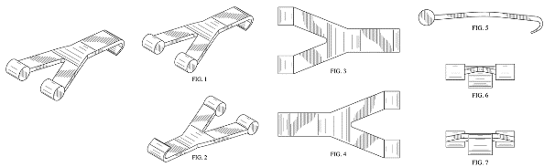 |  | Apparel & Accessories
YURMAN |  | Apparel & Accessories
ZIIIRO |  | Apparel & Accessories
Moynat |  | Apparel & Accessories
Wayfarer |  | Apparel & Accessories
Living Lockets |  | Apparel & Accessories
Alex and Ani |  | Apparel & Accessories
Boucheron |  | Apparel & Accessories
Christopher Kane |  | Apparel & Accessories
Girard-Perregaux |  | Apparel & Accessories
JeanRichard |  | Apparel & Accessories
mcq |  | Apparel & Accessories
Pomellato |  | Apparel & Accessories
Qeelin |  | Apparel & Accessories
ulysse nardin |  | Apparel & Accessories
Electric |  | Apparel & Accessories
Tretorn |  | Apparel & Accessories
fischer |  | Apparel & Accessories
amway |  | Apparel & Accessories
costco |  | Apparel & Accessories, Houseware
rock & republic |  | Apparel & Accessories, Jewelry
12 TWELVE SOUTH |  | Consumer Electronics
3Doodler |  | Consumer Electronics
Aleratec |  | Consumer Electronics
apple |  | Consumer Electronics
AMERICAN POWER CONVERSION |  | Consumer Electronics
AUDIMUTE |  | Consumer Electronics
AudioQuest |  | Consumer Electronics
Avantree |  | Consumer Electronics
B&W |  | Consumer Electronics
Bacpac |  | Consumer Electronics
BeatBox |  | Consumer Electronics
belkin |  | Consumer Electronics
BOSCH |  | Consumer Electronics
BOSE |  | Consumer Electronics
BOWERS & WILKINS |  | Consumer Electronics
Braven |  | Consumer Electronics
c5 |  | Consumer Electronics
Camtree |  | Consumer Electronics
Canalsat |  | Consumer Electronics
CANDYSHELL |  | Consumer Electronics
Chelsea Football Club |  | Consumer Electronics
Compass |  | Consumer Electronics
COOLFIRE |  | Consumer Electronics
CORTEX |  | Consumer Electronics
Covert |  | Consumer Electronics
CRUZER CROSSFIRE |  | Consumer Electronics
S-VIEW |  | Consumer Electronics
d&b audiotechnik |  | Consumer Electronics
DEFA |  | Consumer Electronics
DEHN |  | Consumer Electronics
Dolby |  | Consumer Electronics
dolby digital |  | Consumer Electronics
EARPODS |  | Consumer Electronics
Elnec |  | Consumer Electronics
ENELOOP |  | Consumer Electronics
EPI |  | Consumer Electronics
ESET |  | Consumer Electronics
FERMAX |  | Consumer Electronics
FLYGRIP |  | Consumer Electronics
FOCAL the spirit of sound |  | Consumer Electronics
Fosmon |  | Consumer Electronics
Fuji Xerox |  | Consumer Electronics
Gaminator |  | Consumer Electronics
GoPro |  | Consumer Electronics
GreatShield |  | Consumer Electronics
GRIFFIN |  | Consumer Electronics
Hero |  | Consumer Electronics
HI-FUN |  | Consumer Electronics
hi-Fun hi-Call |  | Consumer Electronics
HMDX |  | Consumer Electronics
Hypercel |  | Consumer Electronics
HYPERX |  | Consumer Electronics
ICOM |  | Consumer Electronics
iGuy |  | Consumer Electronics
INCIPIO |  | Consumer Electronics
INOX CASE |  | Consumer Electronics
INSTAR |  | Consumer Electronics
JBL |  | Consumer Electronics
J-Link |  | Consumer Electronics
JOBY |  | Consumer Electronics
JUICE PACK POWERSTATION |  | Consumer Electronics
Kaspersky |  | Consumer Electronics
Kaspersky Anti-Virus |  | Consumer Electronics
KATE SPADE SATURDAY |  | Consumer Electronics
KEIL |  | Consumer Electronics
KICKASS POWER |  | Consumer Electronics
KODAK |  | Consumer Electronics
Konami |  | Consumer Electronics
Lexmark |  | Consumer Electronics
LOWEPRO |  | Consumer Electronics
MAIXIN |  | Consumer Electronics
MAKERBOT |  | Consumer Electronics
Marley |  | Consumer Electronics
Marvel |  | Consumer Electronics
Maxboost |  | Consumer Electronics
megawin |  | Consumer Electronics
Melkco |  | Consumer Electronics
Micro SD |  | Consumer Electronics
MIFARE |  | Consumer Electronics
MIMOBOT |  | Consumer Electronics
MMarley |  | Consumer Electronics
MOPHIE JUICE PACK PLUS |  | Consumer Electronics
MOPHIE JUICE PACK POWERSTATION |  | Consumer Electronics
MSR606 |  | Consumer Electronics
MTE |  | Consumer Electronics
MUSUBO |  | Consumer Electronics
MY BOOK |  | Consumer Electronics
MY PASSPORT |  | Consumer Electronics
MyGift |  | Consumer Electronics
NABI |  | Consumer Electronics
Nady |  | Consumer Electronics
NAGOYA |  | Consumer Electronics
nanostation |  | Consumer Electronics
Native Union |  | Consumer Electronics
naztech |  | Consumer Electronics
NCOMPUTING |  | Consumer Electronics
NIGHTFORCE |  | Consumer Electronics
NoiseHush |  | Consumer Electronics
Pajamas for Your Ears |  | Consumer Electronics
PNOZ |  | Consumer Electronics
PONG |  | Consumer Electronics
POWERJOLT |  | Consumer Electronics
PURE.GEAR |  | Consumer Electronics
Quad Lock |  | Consumer Electronics
QUIETCOMFORT |  | Consumer Electronics
Quik Pod |  | Consumer Electronics
R&M |  | Consumer Electronics
RealView |  | Consumer Electronics
mifi |  | Consumer Electronics
SAMSUNG |  | Consumer Electronics
sdhc |  | Consumer Electronics
SHARP |  | Consumer Electronics
soundlink |  | Consumer Electronics
TRIDENT CASE |  | Consumer Electronics
TUDIA |  | Consumer Electronics
UBNT |  | Consumer Electronics
UNU |  | Consumer Electronics
VANS |  | Consumer Electronics
WACOM |  | Consumer Electronics
wd |  | Consumer Electronics
Western Digital |  | Consumer Electronics
XEROX |  | Consumer Electronics
Yurbuds |  | Consumer Electronics
ZEM |  | Consumer Electronics
NXP |  | Consumer Electronics
GRIFFIN |  | Consumer Electronics
Acer |  | Consumer Electronics
Spiderpodium Tablet |  | Consumer Electronics
86hero  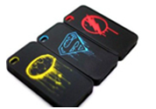 |  | Consumer Electronics
AmpliTube |  | Consumer Electronics
samsung |  | Consumer Electronics
apple  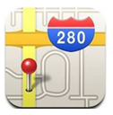 |  | Consumer Electronics
Arduino |  | Consumer Electronics
bookbook |  | Consumer Electronics
Brother |  | Consumer Electronics
Case-Mate |  | Consumer Electronics
Commuter |  | Consumer Electronics
Element Case |  | Consumer Electronics
GIZMON  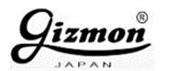 |  | Consumer Electronics
GRIFFIN |  | Consumer Electronics
happymori |  | Consumer Electronics
HYUNDAI |  | Consumer Electronics
ICOM |  | Consumer Electronics
iRig |  | Consumer Electronics
ixus |  | Consumer Electronics
MOPHIE JUICE PACK |  | Consumer Electronics
Mojang |  | Consumer Electronics
Oki |  | Consumer Electronics
olloclip |  | Consumer Electronics
Vaio |  | Consumer Electronics
MSR606 |  | Consumer Electronics
Minidx |  | Consumer Electronics
TRIPORT |  | Consumer Electronics
CM |  | Consumer Electronics
Elnec |  | Consumer Electronics
Starlogic |  | Consumer Electronics
M in solid circle |  | Consumer Electronics
Plantronics |  | Consumer Electronics
RAZER |  | Consumer Electronics
Cruzer  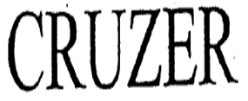 |  | Consumer Electronics
SD |  | Consumer Electronics
SMS AUDIO |  | Consumer Electronics
Play Station |  | Consumer Electronics
USBEE |  | Consumer Electronics
XPERIA |  | Consumer Electronics
abee |  | Consumer Electronics
Geovision |  | Consumer Electronics
CISCO |  | Consumer Electronics
Zalman |  | Consumer Electronics
TRIDENT |  | Consumer Electronics
Incipio |  | Consumer Electronics
LIFEPROOF  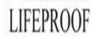 |  | Consumer Electronics
Switcheasy  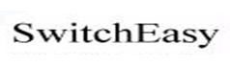 |  | Consumer Electronics
Adobe |  | Consumer Electronics
AKG |  | Consumer Electronics
Apple |  | Consumer Electronics
Asus |  | Consumer Electronics
Audio Technica |  | Consumer Electronics
Audioquest |  | Consumer Electronics
Aura (Motorola系列) |  | Consumer Electronics
Bang & Olufsen |  | Consumer Electronics
Beats by Dr. Dre |  | Consumer Electronics
Benq |  | Consumer Electronics
Blackberry |  | Consumer Electronics
Bose  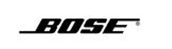 |  | Consumer Electronics
Canon |  | Consumer Electronics
Capdase |  | Consumer Electronics
Celestica |  | Consumer Electronics
Compaq |  | Consumer Electronics
Corsair |  | Consumer Electronics
Data Traveler (Kingston系列)  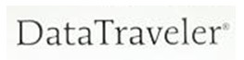 |  | Consumer Electronics
Dell |  | Consumer Electronics
Dopod |  | Consumer Electronics
DS, NDS, NDSL (Nintendo系列) |  | Consumer Electronics
Eonon |  | Consumer Electronics
EOS (Canon系列) |  | Consumer Electronics
Epiphone |  | Consumer Electronics
Epson |  | Consumer Electronics
Game Boy Advance (GBA) |  | Consumer Electronics
Garmin |  | Consumer Electronics
Geovision |  | Consumer Electronics
Goldvish |  | Consumer Electronics
Hitachi |  | Consumer Electronics
HP (Hewlett Packard) |  | Consumer Electronics
HTC |  | Consumer Electronics
IBM |  | Consumer Electronics
iLuv |  | Consumer Electronics
iMac |  | Consumer Electronics
Incase |  | Consumer Electronics
Inspiron |  | Consumer Electronics
Intuit |  | Consumer Electronics
iPad |  | Consumer Electronics
iPhone |  | Consumer Electronics
iPod |  | Consumer Electronics
Jabra |  | Consumer Electronics
JBL by Harman  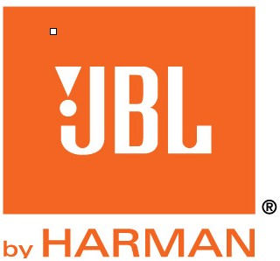 |  | Consumer Electronics
Kenwood |  | Consumer Electronics
Kingston |  | Consumer Electronics
Spiderpodium Tablet |  | Consumer Electronics
MSR606 |  | Consumer Electronics
Minidx |  | Consumer Electronics
TRIPORT |  | Consumer Electronics
CM |  | Consumer Electronics
Elnec |  | Consumer Electronics
Starlogic |  | Consumer Electronics
M in solid circle |  | Consumer Electronics
Plantronics |  | Consumer Electronics
RAZER |  | Consumer Electronics
Cruzer |  | Consumer Electronics
SD |  | Consumer Electronics
SMS AUDIO |  | Consumer Electronics
Play Station |  | Consumer Electronics
USBEE |  | Consumer Electronics
XPERIA |  | Consumer Electronics
Klipsch |  | Consumer Electronics
Koss |  | Consumer Electronics
Lumix |  | Consumer Electronics
Mac |  | Consumer Electronics
MacBook |  | Consumer Electronics
Meizu M8 |  | Consumer Electronics
Microsoft |  | Consumer Electronics
Microsoft Office Live (Microsoft系列) |  | Consumer Electronics
Mobiado |  | Consumer Electronics
Monster Cable |  | Consumer Electronics
Mophie |  | Consumer Electronics
Motorola |  | Consumer Electronics
MS Access (Microsoft系列) |  | Consumer Electronics
MS Exchange Server (Microsoft系列) |  | Consumer Electronics
MS SQL Server (Microsoft系列)/td> |  | Consumer Electronics
MS Visio (Microsoft系列) |  | Consumer Electronics
MS Windows (Microsoft系列) |  | Consumer Electronics
Naztech |  | Consumer Electronics
Netac |  | Consumer Electronics
Nikon  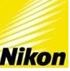 |  | Consumer Electronics
Nintendo |  | Consumer Electronics
Nokia |  | Consumer Electronics
Olympus |  | Consumer Electronics
Otter Box  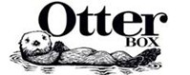 |  | Consumer Electronics
Palm |  | Consumer Electronics
Pioneer |  | Consumer Electronics
Plantronics  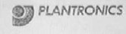 |  | Consumer Electronics
Playstation (PS) |  | Consumer Electronics
Pure Acoustics |  | Consumer Electronics
Samsung |  | Consumer Electronics
Sandisk |  | Consumer Electronics
Seidio |  | Consumer Electronics
Sennheiser |  | Consumer Electronics
Shure |  | Consumer Electronics
Skullcandy |  | Consumer Electronics
Sony  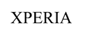 |  | Consumer Electronics
Sony Ericsson |  | Consumer Electronics
Speck |  | Consumer Electronics
Starlogic |  | Consumer Electronics
Switcheasy |  | Consumer Electronics
Symantec |  | Consumer Electronics
Toshiba |  | Consumer Electronics
Vaio (Sony系列)  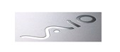 |  | Consumer Electronics
Vertu |  | Consumer Electronics
Vinyl Express |  | Consumer Electronics
Wii |  | Consumer Electronics
Xbox (Xbox 360) |  | Consumer Electronics
Zumreed |  | Consumer Electronics

