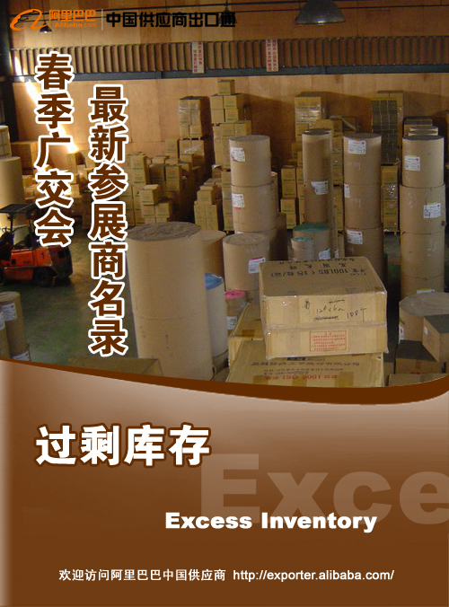

国家 | 公司名称 | 产品求购链接 | 求购产品 | 描述详情 | 发布日期
Germany | K. H. S. Service | http://www.alibaba.com/buyofferdetail/102106878/Looking_For_Overstocks_Over_Capacity_Any_Product_Welcome_.html | Looking For Overstocks / Over Capacity-Any Product Welcome! ! | IF YOU HAVE OVERCAPACITY OR OVERSTOCKS OF ANY ITEM  PLEASE SEND YOUR OFFER incl. pictures and pricelist. | 02-MAY-09
United States | Ebeling Engineering, Inc | http://www.alibaba.com/buyofferdetail/102113948/Overstock_or_abandoned_inventory_wanted.html | Overstock or abandoned inventory wanted | We are looking for high volume abandoned or overstocked inventory for purchase. Needs to be from overseas suppliers only!!!! | 04-MAY-09
Hong Kong | Win Trade Gz L | http://www.alibaba.com/buyofferdetail/102116023/Single_jersey_Knit_Fabric.html | Single jersey / Knit Fabric | We are looking for Knit & Single jersey fabric stock | 04-MAY-09
Australia | NEW ZEALAND STYLES | http://www.alibaba.com/buyofferdetail/102119395/authentic_reliable_undisturbed_shipping_suppliers.html | authentic reliable undisturbed shipping suppliers | my clients are seeking all products in all catagories but you must be authentic, reliable and able to provide regular shipments. | 05-MAY-09
Costa Rica | www.PequenoMundo.com | http://www.alibaba.com/buyofferdetail/102050304/Tableware_Assorted_Items_Melamine_stock.html | Tableware Assorted Items Melamine stock | We have 8 department stores 3000 square meters each.  We are interested in buying 1x40hq of melamine tableware (stock) . | 17-APR-09
Hong Kong | Rajko Traders(HK) Limited | http://www.alibaba.com/buyofferdetail/102047822/excess_inventory.html | excess inventory | We are Looking stocks | 17-APR-09

国家 | 公司名称 | 产品求购链接 | 求购产品 | 描述详情 | 发布日期
United Kingdom | locate global LTD | http://www.alibaba.com/buyofferdetail/102049923/Excess_DVDs_wanted.html | Excess DVDs wanted | Dvd movies wanted | 17-APR-09
United States |  | http://www.alibaba.com/buyofferdetail/101929012/USER_MANUALS_INSTRUCTION_.html | USER MANUALS/ INSTRUCTION | LOOKING TO BUY ORIGINAL IWC BOX , ORIGINAL INSTRUCTION MANUAL MAINLY FOR THE BIG PILOT AND OTHER MODELS. | 12-MAR-09
Pakistan | A-Dealing Center | http://www.alibaba.com/buyofferdetail/101934167/BABY_DIAPERS.html | BABY DIAPERS | WE ARE LOOKING EXCESS INVENTORIES CLOSE OUTS FACTORY AXCESS STOCK LOTS FOR BABY DIAPERS, ADULT DIAPERS, LADIES SANITORY PADS | 14-MAR-09
Australia |  | http://www.alibaba.com/buyofferdetail/101949609/WE_BUY_ALL_EXCESS_STOCK_CLOSEOUTS_FAULT_PRODUCTION_CANCELLED_ORDERS.html | WE BUY ALL EXCESS STOCK, CLOSEOUTS, FAULT PRODUCTION, CANCELLED ORDERS | Our Buyers will be in China April 2009, contact them to buy all your excess, cancelled orders, production faults, stock orders! | 18-MAR-09
India |  | http://www.alibaba.com/buyofferdetail/101950700/all_type_of_latest_products_for_re_sale.html | all type of latest products for re sale | we are importer & wholesaler of all type products | 19-MAR-09
United States |  | http://www.alibaba.com/buyofferdetail/101961754/Everything_overstock.html | Everything overstock | Hello,  My name is Debra Bouchard and my company buys huge warehouses/truckloads of inventory with CASH Up Front. Please visi | 22-MAR-09

国家 | 公司名称 | 产品求购链接 | 求购产品 | 描述详情 | 发布日期
Bangladesh | Crystal Corporation | http://www.alibaba.com/buyofferdetail/101967167/Wanted_E_G_COIL.html | Wanted E G COIL | E G COILS | 23-MAR-09
France |  | http://www.alibaba.com/buyofferdetail/101969627/Buy_all_bulk_wholesale_overproduction_stocks_.html | Buy all bulk , wholesale , overproduction , stocks | MP INTERNATIONAL  We buy all kind of excess stock , or overproductions  but also new manufactured items from the factories. | 24-MAR-09
United States | AQUARIAN CONCEPTS | http://www.alibaba.com/buyofferdetail/101970821/surplus_General_Merchandise.html | surplus General Merchandise | We are looking for bulk quantities of general merchandise. calculators, alarm clocks, | 24-MAR-09
United States |  | http://www.alibaba.com/buyofferdetail/101978744/all_cheap_stuff.html | all cheap stuff | direct | 26-MAR-09
India |  | http://www.alibaba.com/buyofferdetail/101981278/glossy_papers.html | glossy papers | wwe require glssy papers | 27-MAR-09
United States |  | http://www.alibaba.com/buyofferdetail/101986834/Architectural_Model_Supplies.html | Architectural Model Supplies | Architectural Model Supplies | 29-MAR-09
» 查看更多本行业求购信息请访问 exporter.alibaba.com

